CRAUGHWELL GAA
NEWSLETTER

MAY 2020

Welcome to Craughwell GAA Newsletter. We hope this finds you all in good health in these uncertain times.
Throughout the Covid-19 lockdown, we have endeavoured to stay in touch with our members and the community through the various media platforms. This has included profiles on some of our members, a look back in the archives, and running Facebook & Twitter competitions, which have proved hugely popular.
In this newsletter, we take a look at some of the things that have taken place in the club over the last six months. In addition, Juvenile Chairman Shane Comer interviews Craughwell GAA supporter Benny Kenny and Shane has also created a ‘Healthy Corner’, where you will find some useful tips. We hope you enjoy.
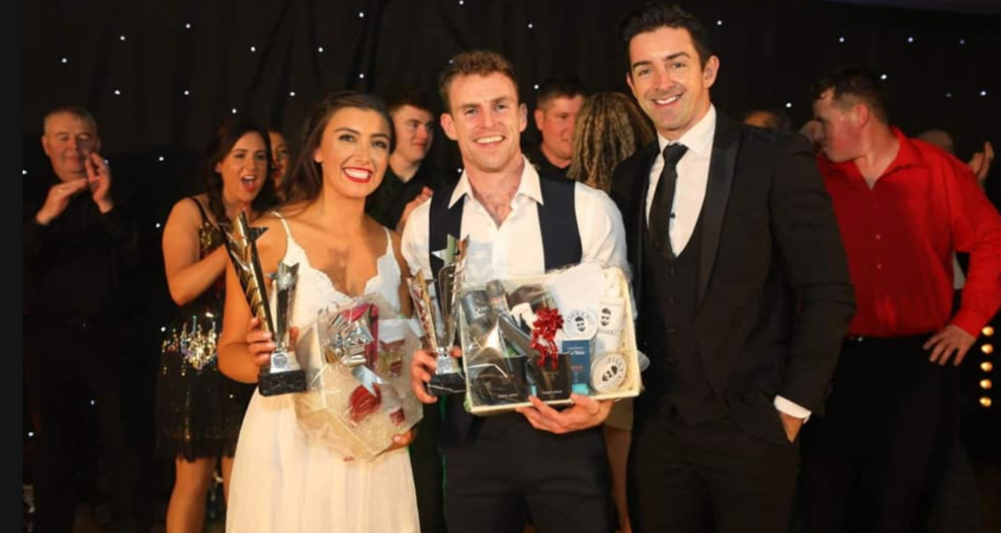Creating a Future:
On November 9th, 2019, a new era began for Craughwell GAA Club at the Clayton Hotel, Galway. In a packed to capacity ballroom (800 plus people), we watched 12 couples dance, as they aimed to be crowned Craughwell’s ‘Strictly’ winners. In the end, that honour fell to Holly Whiriskey and Ger O’Halloran, the couple starring with a wonderful display on the night.
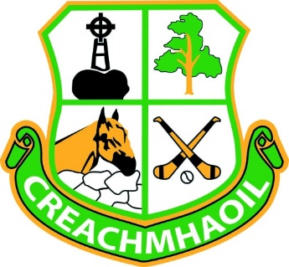
Thanks to our amazing dancers and sponsors, the above event raised €90,000 (including the additional grant) and, as you may be aware, the club is using this money to develop its facilities as it continues to serve club members and the community.
At juvenile level, hurling, football and camogie members use our facilities daily while we also cater for hurling and camogie at adult level. Indeed, with over 500 juvenile registrations – and our community to grow in the years ahead – it’s vital that investment is put into our facilities for our children and grandchildren.
Our first project is the ball wall and a new Astroturf area. With a total cost of €92,000, work commenced in early March. An Astroturf on both sides of the ball wall, with fencing, will bring value to the ball wall and provide a safe environment for our children and adults.
A down payment of €17,000 was provided for work to commence and raw material to be purchased. To date, excavation work has been carried out while the underlay, gates and boundary fencing has also been purchased.
Fencing was due to have been erected on Monday March 30th but due to Covid-19 the site has been closed.
Watch this space for an update on our next community event and Phase 2.
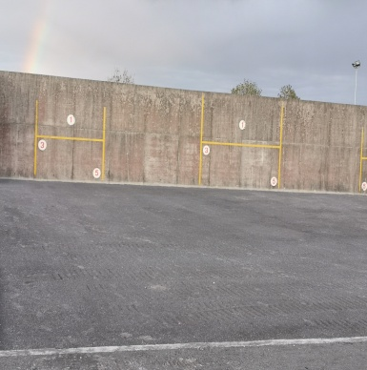

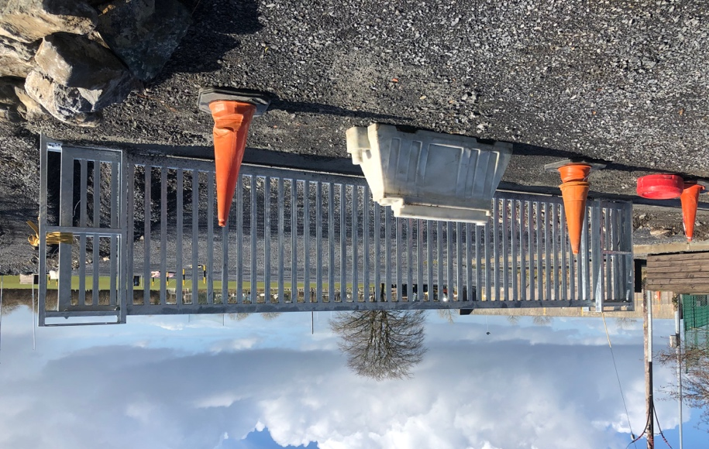
Covid-19 Volunteers:
A special word of thanks goes out to all those who offered to become volunteers and help to bring shopping from Jody’s and prescriptions from Craughwell Pharmacy to the elderly and the vulnerable.
To date over 70 deliveries have been made within the parish to Killeeneen, St Cleran’s, Blackgarden, Colemans, Ganty, Caherdine, Ballymanagh and many more townlands. It’s great to see that in times like this that community spirit is alive and well within our GAA club.
For the vulnerable and elderly people within our parish, it’s important they are aware that we, the younger generation, are here to help them in their time of need – and even beyond this point.
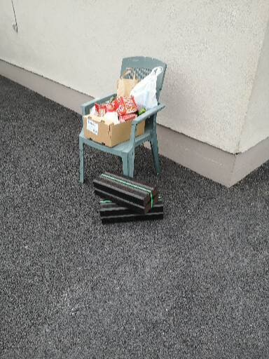
Covid-19 Drills and Challenges:
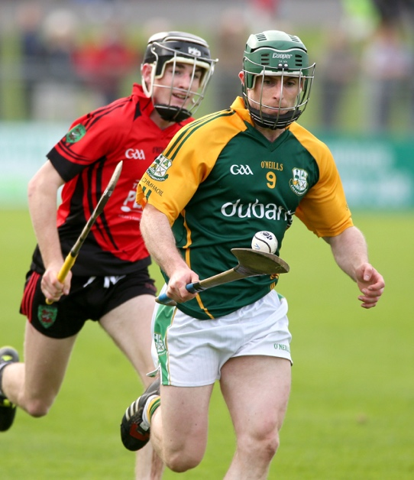
Thanks to Craughwell senior hurler Ger O’Halloran for his fitness & exercise videos. See our Facebook page for demonstrations.

Elevated Push Ups Triceps Dips
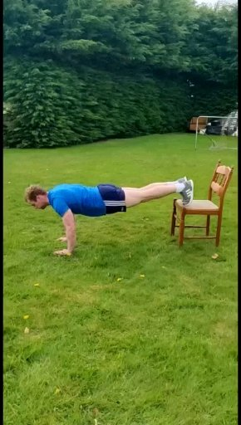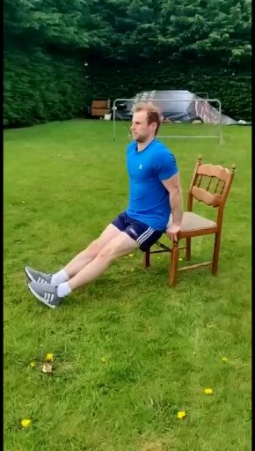

Other videos:

A number of other video are available on our Facebook and Twitter pages. One is from former Galway star and Craughwell hurler Niall Healy.
In the video, the aim was to see how many consecutive strikes a player can get off the wall without taking the ball in their hand or without touching the ground. Position five metres back from wall.
Also showcasing their skills were:
- Gavin Clarke: Striking ball of wall and catching.
- John Donnellan showing Pentagon Hurling Station (with Charlie explaining).
- Liam Reilly - Free Styling.
- Eoin Middleton doing circuit.
- Roan Healy and Finn (aged 3) in his Spider-Man costume showing ground strike to our U6/7’s group.

Again, many thanks to Ger O Halloran, Niall Healy and all the kids for sharing their videos. We had so many. Keep sending them forward and we will share more in our next edition.
GAA Auction:
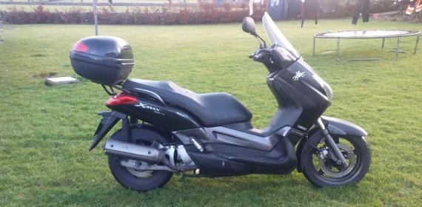
The annual Craughwell GAA Auction took place on Saturday evening, March 7th, in Cheevers.
All proceeds from the auction go to the daily running cost of Craughwell GAA Club. As noted, we are a club with growing juvenile numbers along with four teams at adult level.
With a number of donations from families in the parish, we had over two hundred items up for auction, ranging from silage, turf, wood, weekends away, restaurant vouchers, concert tickets, hampers, spirits, spa treatments, massages and, of course, the Yamaha 125 Scooter from Benny Kenny.
On the night, the club raised €15,000. Thanks to Colm Farrell, (Auctioneer), Maggie Ryan, Yvonne Kelly, Mike Kelly and Frank Healy (Auction Committee), Mary and John Cheevers and, most of all, those of you who attended and purchased on the night.
Without your continued support and generosity, the night would not be the success it was.
Juvenile Chairman Shane Comer speaks to Benny Kenny
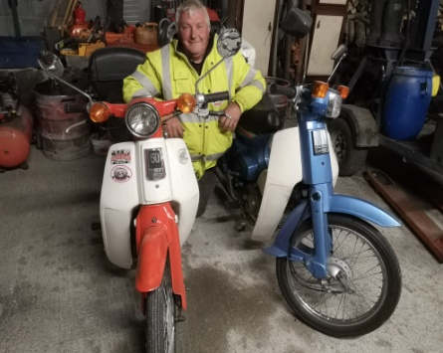
Since this was the third bike donated from Mr Benny Kenny, I decided to ask Benny a few questions on where his interest in bikes comes from. Here’s what he had to say.
It all started as a new hobby back in 2012. Although he had no previous experience on bikes, Benny travelled to Cork and purchased his first bike which was a Honda 50. The bike was in four parts ready to be dumped. He continued to purchase another two bikes: one in Thurles, which was again in a box ready to be dumped, and the second was broken up in two, with one half in a bag.
He began to sandblast each of them and contacted suppliers of parts, in Leitrim and, more locally, Kylebrack. Having all three bikes back to working order within nine months, Benny’s first sale was to Peter Dolan from Mannin, Craughwell. From this point, his hobby took off, with the second sale to Liam Joyce.
Seeing that there was a growing interest in the Honda 50 comeback, the three men decided to set up a little charity called Craughwell Motorcycle Club. A committee was then formed (Benny Kenny, Mary Kenny, Peter Dolan, Liam Joyce, Packie Martyn, Seam Smyth, Gerry Maloney, Vinnie Monaghan and Gerry Fahy) in order to organise the Honda 50 Charity Runs which take place each July. Sadly, due to Covid-19, this will not be taking place this year. Growing each year, the third annual event in 2019 saw 75 participants from all over Ireland leave Craughwell Village on their Honda 50s.
Each run covers 55 miles (approx.), stopping off at different locations and raising much needed funds. To date they have raised over €25,000 for their main charity, Autism Ireland.
Currently, Benny has two Honda 50s completed and a further two in his workshop. I stand to be corrected, one body of a Honda 50 and parts of another! No doubt, both will be brought back to life. Indeed, we may even see one of them at the next Craughwell GAA Action.
Thanks to both Mary and Benny Kenny and Peter Dolan for providing me with the above information. Here’s too many more years of the Honda 50 hobby.

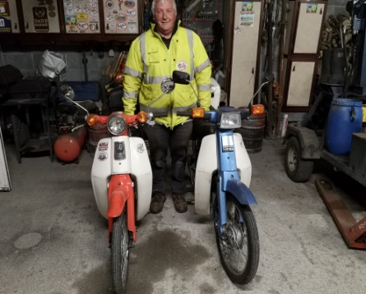

PROTECT YOURSELF AND OTHERS FROM CORONAVIRUS:
Everyone needs to stay at home to help slow the spread of coronavirus. You should only leave for essential reasons. This is the best way to protect you family, friends and community. It’s important to practice social distancing and wash your hands often.
AT RISK GROUPS:
There are some groups of people who may be at risk of serious illness if the catch coronavirus. These people need to take extra care to protect themselves. This is on top of the advice that everyone needs to follow. At risk groups include:
- Long term medical conditions for example, heart disease, lung disease, diabetes, cancer, cerebrovascular disease, liver disease, renal disease and high blood pressure
- If you have a weak immune system.
- Have a medical condition that can affect your breathing
- Residents of nursing home and other long-staying settings
- Specialist disability care and are over 50 years of age or having a underlying health problem.

HEALTH & WELLBEING CORNER

Over the last number of weeks, there has been an increase in the amount of fruit being eating in the family home. Juvenile Chairman Shane Comer decided to take a closer look at the vitamins and advantages of eating fruit on a daily basis and learned fruit is designed by nature to be eaten and is the most natural food there is. Eating fruit is not only essential for us, it’s vital for the environment.
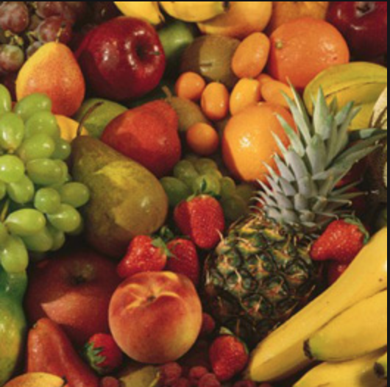
- Apple: Source of Vitamin C which is vital for growth and repair of body tissue, keeping teeth and gums healthy and healing cuts and wounds.
- Orange: Source of vitamin C, fibre and potassium. They are also a source of folate which helps babies from developing spina bifida during pregnancy.
- Pear: Source of potassium which helps to control heart rate and blood pressure.
- Blueberry: High in Manganese, source of vitamin C and fibre. Manganese helps to break down fats, protein and carbohydrates. It also helps with normal growth.
- Nectarine: Source of antioxidants which help neutralise free radicals.
- Red Grapefruit: High in vitamin C. Free of all bad cholesterol and helps to boost immune system.
- Raspberries: Naturally low in fat, calories and sodium. Helps our digestion system.
- Strawberries: High in vitamin C. As above helps with digestion and breaks down fats, protein and carbohydrates.
- Mango: Source in fibre, vitamin E and high in vitamin C. Helps to reduce cholesterol levels and reduces toxins around the bowel. It also keeps nerve and red blood cells healthy.
- Bananas: High in potassium. Contains tryptophan which is believed to improve mood.
Good to eat when suffering from cramp. The inside of the banana skin also works on mosquito bites.
- Melons: Source of potassium and Vitamin C. Melons contain the antioxidant, lycopene which may lower the risk of cancer. The potassium and magnesium in watermelons is understood to help reduce blood pressure.
- Grapes: Source of potassium. According to research grapes are a nourishing, strengthening, cleansing and a regenerative food. Good for helping with fatigue, arthritis and migraine.
To those in our community who are doctors, nurses, health care assistants, catering, cleaning and administration staff in our hospitals and nursing homes, to our guards, retail staff, food producers and logistics who are delivering nationwide on a daily basis, a sincere thank you from Craughwell GAA Club. You all have been a credit to our village.

Frozen Berries Yoghurt
Serves 4-6

When kids eat lots of fruit as part as a balanced diet health experts say that they concentrate better and have more energy for spots. The great thing with fruit it can be eaten at any time of the day, as a snack or included with breakfast, lunch or dinner. This is something quick and handy to make from berries. Here’s what you need for Berry Frozen Yogurt:

100g Blackberries
100g Raspberries
100g Strawberries
6 tsp honey
600ml low fat natural yoghurt

1. Place all berries into a bowel and mash with a fork.
2. Add honey and yogurt and mix until smooth.
3. Transfer mix to an airtight container and place in freezer for 2 hour.
4. Remove from freezer and scoop into a bowel as you would ice cream.

